custom exception

Workshop #03

Flutter Developer Bootcamp

# **Purpose**

The purpose of the above code is to demonstrate how to create a custom exception in Dart.

# **Problem**

In the given workshop, When the code is executed, it will throw the MyCustomException with the provided message, and the catch block will catch it. Then, it will print the exception message which includes both the name of the exception class (MyCustomException) and the custom message provided during instantiation.

# **How to Solve**

1. Checkout the workshop from Git Repo:

git clone -b <user-branch> <repo-URL>

2. Open the root folder inside VS Code

3. Open the root folder in terminal

4. Run the command dart run filename.dart

5. Create a custom exception error message and throw it

# **You Will Achieve**

* A custom exception class MyCustomException is defined, which implements the Exception interface. It has a constructor that takes a message parameter.
* The toString() method is overridden to provide a custom string representation of the exception, which includes the message.
* In the main() function:
  + A try block is used to encapsulate code that might throw an exception.
  + Inside the try block, an instance of MyCustomException is thrown with a custom message.
  + The catch block catches any exception thrown within the try block.
  + The caught exception (e) is printed using print(e).

So, when you run this code, it will throw an instance of MyCustomException with the message "This is a custom exception message.", and then catch and print that exception.

# **Screenshots**

## **Before implementation (without Custom Exception)**

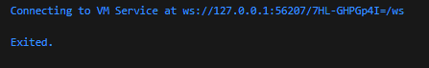

## **After implementation (With Custom Exception)**

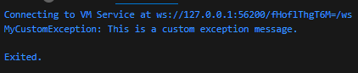

# **How to submit your workshop**

Push your project back to the same git branch using command:

<command name>

# **Happy Coding!**